Denton Village Hall

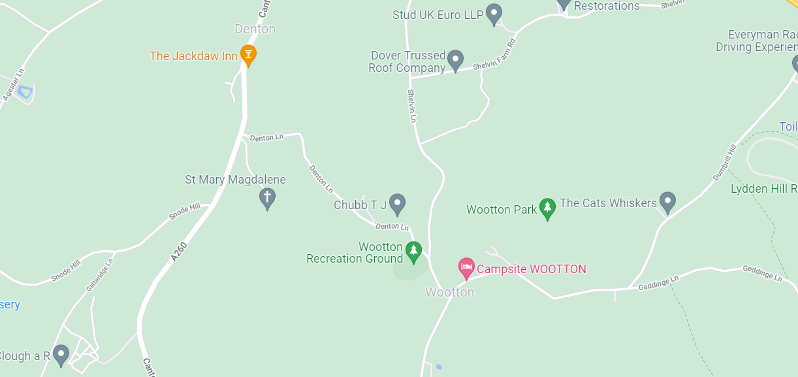
Wootton Village Hall

